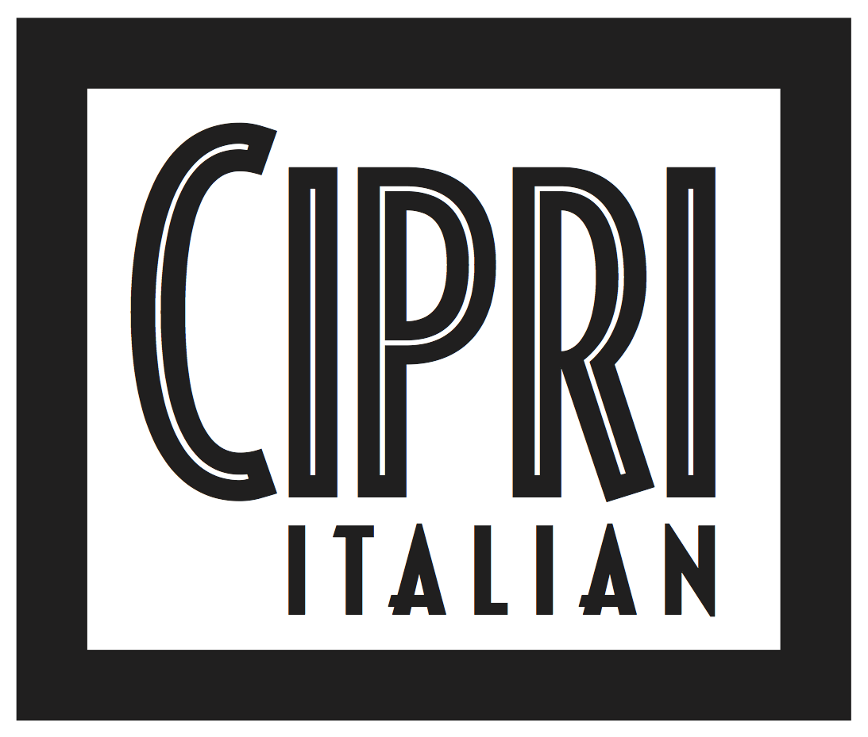

FUNCTION MENU - OVER 20 PEOPLE

2 course – ANTIPASTO OR PASTA, & MAIN from $90
Including assaggi & contorni

3 course – ANTIPASTO, PASTA, & MAIN from $110
Including assaggi & contorni

ASSAGGI
(Included to share)
Arancini, basil pesto, mozzarella, semi dried tomato, charcoal breadcrumb
Italian olives, citrus, rosemary, chilli
Sourdough & focaccia with extra virgin olive oil

ANTIPASTI
(Choose 2 to alternate OR choose 3 to share)
Fish crudo of the day
Beef carpaccio, testun al Barolo cheese, walnut pesto, celery heart, quail eggs gf n
Buffalo mozzarella, beetroot, speck, pickled baby artichoke gf vo
Sformatino di melanzane - baked eggplant, basil & mozzarella sformatino,
tomato coulis, crispy eggplant
Grilled calamari, lemon, crispy herbs, toasted breadcrumbs
Zucchini flowers filled with pesto, mozzarella, ricotta (subject to availability)

PASTA
(Choose 2 to alternate OR choose 2 to share)
Maccheroni, slow braised duck & swiss brown mushroom ragu gfo
Eggplant involtini filled with angel-hair pasta, mozzarella,
pesto, prosciutto (optional) & tomato passata
House made spinach ravioli filled with ricotta & porcini, pumpkin,
burnt butter, sage, toasted hazelnuts n
House made malloreddus, crab, zucchini puree, roasted tomato, lemon breadcrumbs gfo
Orecchiette with pork sausage ragu, rapa, pecorino fondue, ‘nduja crumble gfo

Gluten free - penne or house made chickpea tagliolini available on request
SECONDI
(Choose 2 to alternate OR choose 3 to share)
House made malloreddus, crab, zucchini puree, roasted tomato, lemon breadcrumbs gfo
Orecchiette with pork sausage ragu, rapa, pecorino fondue, ‘nduja crumble gfo
Eggplant involtini filled with angel-hair pasta, mozzarella,
pesto, prosciutto (optional) & tomato passata
Maccheroni, slow braised duck & swiss brown mushroom ragu gfo
Fish of the day
Slow cooked lamb shoulder rolled with herbs,
Sicilian cous cous salad gf (alternating only 40+ people)
Twice cooked suckling pig, red cabbage, pistachio, mustard fruits, jus gf
Grain fed beef scotch fillet 250gr, mbs2+ (Riverine District, NSW)
charred king brown mushroom, rosemary butter gf (alternating only $10 surcharge applies)
La fiorentina - 1kg t-bone, grain fed ‘mbs2+’ (Riverine District NSW), polenta chips, rocket, parmesan, mushrooms, Tuscan salt gf (only for sharing – $60 surcharge applies)

CONTORNI
(Included - choose 2 to share)
Baby gem cos lettuce, radish & hazelnuts, goats cheese vinaigrette n gf
Radicchio, fennel & orange salad, red wine vinegar gf
Crispy cocktail chat potato, rosemary, sea salt, mapuche
Sauteed broccolini, green beans, garlic oil dressing, almond crumble n gf

DOLCE – Additional $16pp
(choose 2 to alternate OR choose 3 to share)
Traditional tiramisu with meringue, chocolate, hazelnut praline n
Almond & rhubarb crème brulee, almond crumble gf, n
Sesame seed cannoli, nougat semifreddo, salted caramel, chocolate soil, orange jaffa gf n
Mixed gelato
(or to share)
Italian cheese platter, quince paste, muscatels, pear, walnut, crispy bread
Mignon dessert platters

